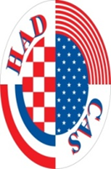

USA MOCK ELECTION PROJECT
Select the next US president in your school....
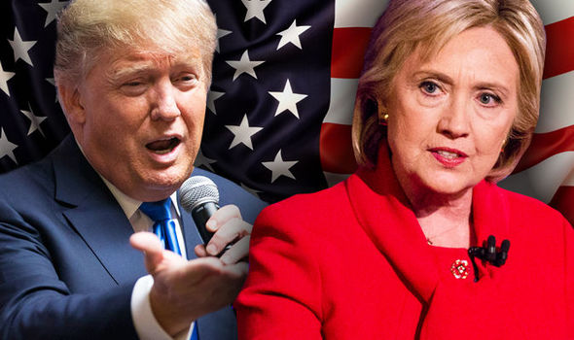

PROJECT COORDINATOR: HRVATSKO-AMERIČKO DRUŠTVO

www.cas.hr

BRINGING AMERICA TO YOU!

